**Activity Risk Assessment**

**Name of Activity / Event**

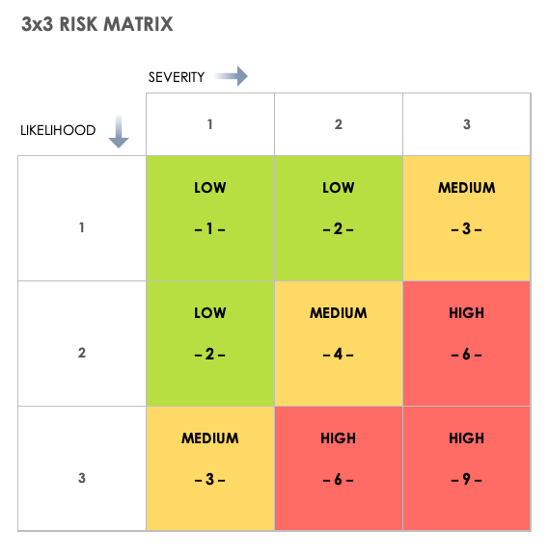

**Venue:** Walsworth Road Baptist Church

**Fire plan / Safety Equipment:** eg WRBC Fire evacuation plan (on [**Church website**](https://www.wrbchitchin.org.uk/documents-policies))

**First Aid Arrangements**: eg First Aid kit & AED in Lower Kitchen; All leaders are current First Aiders

**How you will meet ratios or any other info about the event**:

**Risk assessment carried out by:** **Name** on **date Please also refer to:** eg WRBC Venue RA (on [**Church website**](https://www.wrbchitchin.org.uk/documents-policies))

| **Activity/area** | **Who may be harmed and how?** | **Like-lihood** | **Severity** | **Risk Rating** | **Current Actions** | **Further action required** | **By Whom** | **When** |
| --- | --- | --- | --- | --- | --- | --- | --- | --- |
|  |  |  |  |  |  |  |  |  |
|  |  |  |  |  |  |  |  |  |
|  |  |  |  |  |  |  |  |  |
|  |  |  |  |  |  |  |  |  |
|  |  |  |  |  |  |  |  |  |
|  |  |  |  |  |  |  |  |  |
|  |  |  |  |  |  |  |  |  |
|  |  |  |  |  |  |  |  |  |
|  |  |  |  |  |  |  |  |  |

|  |  |  |  |
| --- | --- | --- | --- |
| **Action** | **Name** | **Signature / notes** | **Date** |
| Agreed by |  |  |  |
| Shared with team members |  |  |  |
| Shared with WRBC |  |  |  |